DESCENDING ORDER

EXP NO.10

AIM: To arrange the numbers in ascending order using 8085 processor.

ALGORITHM:

1. Initialize HL pair as memory pointer
2. Get the count at 4200 into C – register
3. Copy it in D – register (for bubble sort (N-1) times required)
4. Get the first value in accumulator.
5. Compare it with the value at next location.
6. If they are out of order, exchange the contents of accumulator and Memory.
7. Decrement D –register content by 1.
8. Repeat steps 5 and 7 till the value in D- register become zero.
9. Decrement C –register content by 1.
10. Repeat steps 3 to 9 till the value in C – register becomes zero

PROGRAM:

LXI H, 4200H

MOV C, M

DCR C

**REPEAT:** MOV D, C

LXI H, 2201H **LOOP:** MOV A, M

INX H

CMP M

JNC **SKIP**

MOV B, M

MOV M, A

DCX H

MOV M, B

INX H

**SKIP:** DCR D

JNZ LOOP

DCR C

JNZ **REPEAT**

HLT

INPUT:

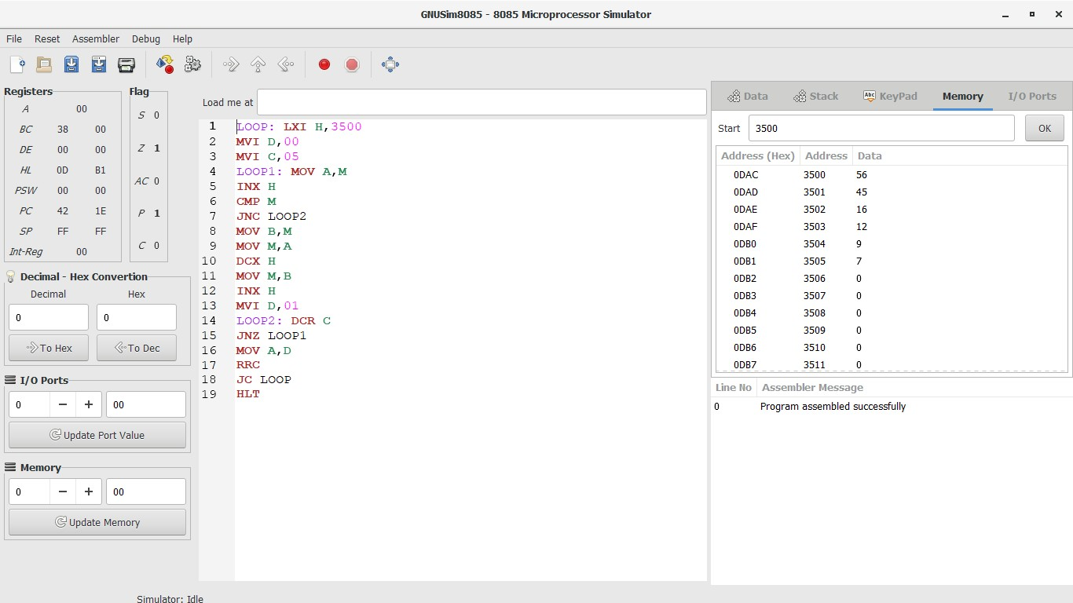

OUTPUT:



RESULT:

Thus the program was executed successfully using 8085 processor simulator.